EXPERIMENT:9: Create a simple cloud software application for Hospital information system for SIMATS Hospital using any Cloud Service Provider to demonstrate SaaS with fields of patient name, age, address, phone, email, Attender name, attender phone, doctor name, diseases, etc.

STEP:1 : CREATE A APPLICATION FORM FOR THE PAITENT DETAILS.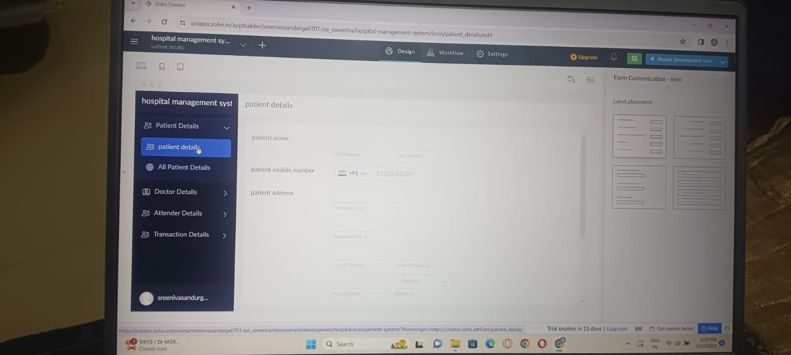

STEP:2 : CREATE A APPLICATION FORM FOR THE DOCTOR DETAILS.

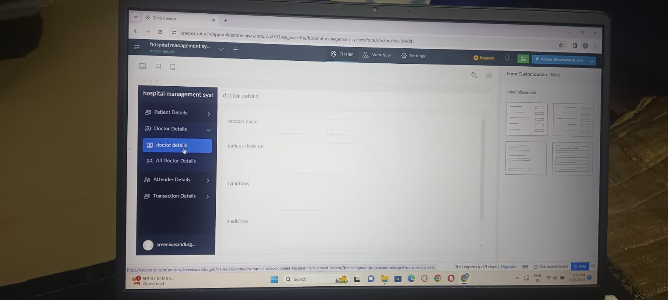

STEP:3: CREATE A APPLICATION FOR THE ATTENDER DETAILS.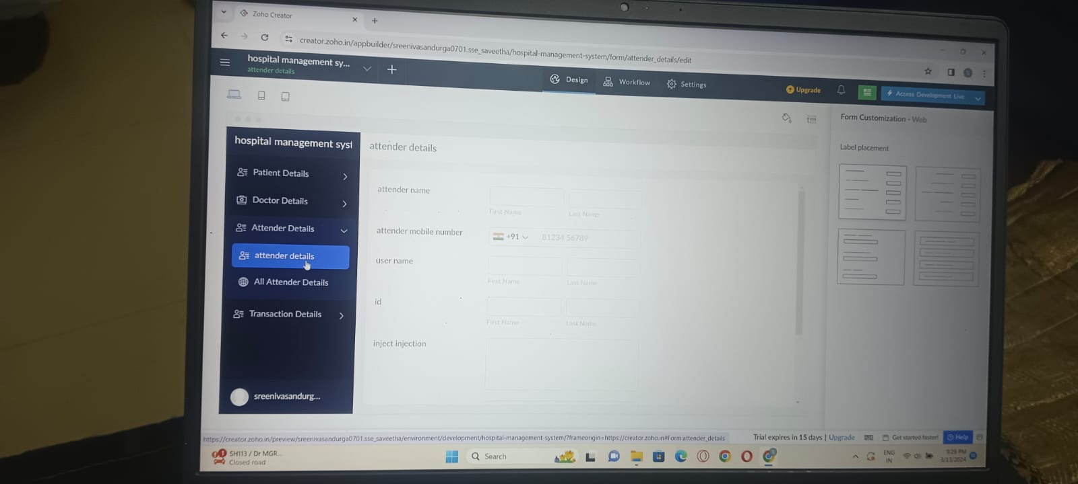

STEP:4: CREATE A APPLICATION FORM FOR THE TRANSACTION DETAILS.

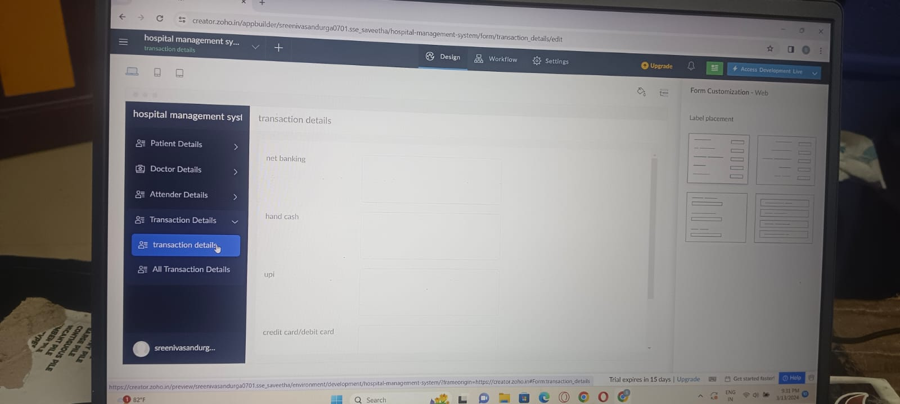

STEP:5 CREATE A APPLICATION FORM FOR THE PAITENT RESULT.

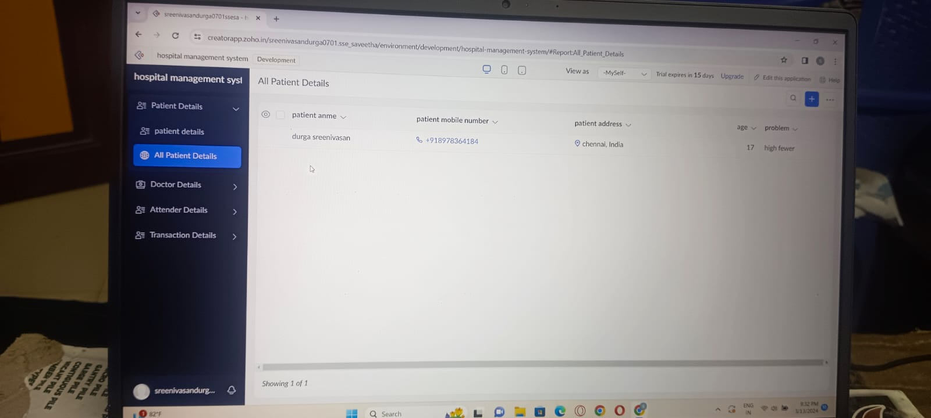

RESULT: THUS, THE PROGRAM FOR THE HOSPITAL MANAGEMENT SYSTEM HAS BEEN EXCEUTED SUCCESSFULLY.